**Introduction:**

**BMI definition:**

Body mass index (BMI) is a statistical measure of weight scaled according to height of any individual. It is a simple index of weight-to-height and is commonly used by medical, health and fitness professionals to classify underweight, overweight and obesity in adults.It is a simple calculation use for classifying people who are not physically active and who have an average body composition, and is generally considered a good indicator of whether you're at a healthy, normal weight for your height.

A body mass index in the low range signals that you could be malnourished. Maybe your body isn’t properly absorbing nutrients or maybe you’re just not getting enough calories to support your activity level. Conversely, having a BMI on the higher end alerts your physician that your risks of heart disease, diabetes and certain cancers are higher than someone with a normal BMI. Your doctor might set you up with a registered dietician, who can help you get your weight back on track and reduce your risk of developing health problems.

it is an important measurement tool. It's an rough indicator of health status and disease risk, based upon weight and degree of obesity According to the American Heart Association(by Robert H.Eekel MD,Ronald M Kruss 1998), as BMI during childhood climbs, so does the risk of coronary heart disease in adulthood. According to Obesity research youngee Kim and Haymie Chio (2012) High rates of diabetes , hypertension and dylipidemia were noted among the people having Low BMI

Socioeconomic Status:

According to Elizabeth H. Baker (Socioeconomic Status, 2014) Socioeconomic status (SES) is defined as a measure of any individual's economic status and social status and frequently behave to be associated positively with normal health. His entry focused on the three common measures of socioeconomic status, that are education, income, and occupation. It include definitions, theoretical background, and empirical support for each of these Socioeconomic Status indicators and their relationships with health/Body Mass index (BMI).

9 of 11 studies reported associations between Socioecnomic effects on BMI, from which some studies references are given below:

(Power C, Hertzman C: Social and biological pathways associating early life and adult disease. Br Med Bull. 1997,

Stronks K, Looman CW, Mackenbach JP: Does childhood socioeconomic status effects adult health through observable factors? 1998

Parker L, Lamont DW, Unwin N, Pearce MS, Bennett SM, Dickinson HO, White M, Mathers JC, Alberti KG, Craft AW: A lifecourse study of risk for hyperinsulinaemia, dyslipidaemia and obesity 2003

oulton R, Caspi A, Milne BJ, Thomson WM, Taylor A, Sears MR, Moffitt TE: Association between children's practice of socioeconomic damage and adult health: a life-course study.2002 )

According to the U.S. Centers for Disease Control and Prevention Michael Pratt, MD, Steven N. Blair, PED; William L. Haskell, PhD; Caroline A. Macera;PhD, 1995) over one-third of U.S. adults are obese. CDC defines obesity as a body mass index equal to or greater than 30. In short, a person 5 feet 4 inches tall is obese if he/she weighs 79 kg or more; a person 5 feet 9 inches is obese if she or he weighs 92 kg or more.

Obesity is sometimes cause of death.It includes heart disease, cancers, stroke, and type 2 diabetes. Although obesity level is rising for almost all socioeconomic groups, and some groups are more affected than other groups. Recent researches draw special attention to the complexity and change in how socioeconomic status (SES) and obesity are related.

An other study by Maria de Bruyn (1992) published in Social Science and Medicine have used data from 67 countries representing almost all regions of the world to inspect how economic development, socioeconomic status, and overweight are related. The researchers used self-reported height and weight to calculate body mass index (BMI), and investigate at the relationship between overweight, gross national product (GNP), and Socioeconomic Status (SES).

"Obesity not only increased with an economic progress but also with socioeconomic status as it disclosed to obesity change", they found. In lower-income countries, people with higher SES were more likely to be higher obese and in opposite, in high-income countries, those with higher SES were less likely to be obese. It may be because of that in lower-income countries, higher SES causes consuming high-calorie food and avoiding physically tasks. But at the same time in higher-income countries, people with higher SES may consume healthy eating and make regular physical activities. The hypothesis is that while economic development improves health, the authors noted that the problems of hunger are replaced by problems of over usage that separately affect SES groups. But some developing countries, such as India, are facing continued high levels of hunger along with a rise in obesity. An other study published in the Sociology of Health and Illness (by Barbara Harrison 2002) examined how weight and lifestyle are related, using data from 17 countries mostly belongs to Europe The researchers found that activities such as reading, attending cultural events, and going to the movies were associated. exercise was with a lower BMI. While on the other aspect, people who participate in activities such as watching TV, sporting events, and shopping etc had higher Body Mass Index. These ways were most consistent in higher-income countries like in western Europe. The author recommended that the activities are “associated with body weight through a possible cause—cultural tastes that in part analyze SES-related group membership.”

Other researchers, in a study published in Demography ,(Paul Mohai, Robin Saha 2006) have also studied at how SES is related to obesity in the progress to early youth in the United States. They found a more nuanced relationship. For instance, men with a middle-class upbringing and lifestyle were almost obese as those brought up in working-poor households but working now in lower-status jobs.And on the other hand for women, the relationships changed by race. For white color women, all SES groups had a greater risk of obesity compared with the most recommended. In comparison, between black women, only those from working-poor ordinary who now had lower-status jobs were at increased obesity risk compared with the most advantaged group.

Overall, these studies show that factors that increase the risk of being obese affect SES groups differently, and may cause disparities in obesity between socioeconomic groups that worsen health and shorten longevity for those who are most disadvantaged.

Most studies on obesity and social status have used only limited measures of socioeconomic position, such as occupational status, self-reported income, or educational fulfillment, usually 1 measure at a time. In addition, studies reporting reduced income levels as a result of irregular body weight are so far restricted to young overweight women.5-7 Furthermore, these studies use self-reported income data, and education or occupation have been used as controlled background variables only.

**Methodology:**

Population Study:

Our population mostly contains students from different universities of Karachi . Sample size is more than260

Data Collection Methods:

The participants were fully informed about the purpose of the study and their consent was obtained before measurements were taken

We used live survey method to collect the data both qualitative and quantitative including age height and other questions

A SES questionnaire used in REVISED SOCIO-ECONOMIC STATUS SCALE FOR

URBAN AND RURAL INDIA (by Guru Raj M.S., Shilpa S., Maheshwaran, R. 2015) was used to collect information on the

subjects’ highest educational attainment, level of income and occupational status. This was used to classify the subjects into the 4 different SE strata

BMI Calculation:

The height and weight were asked individually during survey and we calculated the BMI based on the data collected by individuals using this formula:

Metric unit ::BMI= Weight (kg) / Height (m) x Height (m)

or English Unit :: BMI = Weight (lb) / (Height (in) x(Height (in)) x 703

Measures of socioeconomic status:

Schooling , occupation and Income were asked from the individual during survey and based on that data we calculated the socioeconomic status using following table here

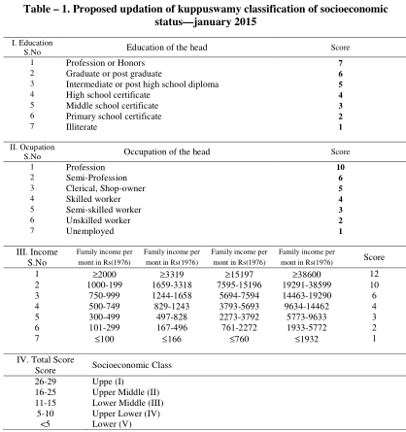

**Results**

The mean age of participant was 20 and mean height 5”5”” ,mean weight is 56 kg and BMI was 20.26 The age of participants was ranged from 13 to 43 years.74 % participants were male while other 36% were female. The participants were mainly young.

Of the study population 300, 55% participants having 55 % having body mass index between 18.5 and 24.9, 34 %having less than 18.5 ,11 % having more than 24.9 while mean BMI of male and female are 20.98 and 18 respectively

Lower class has mean 21.57 BMI, ,Lower middle 20.8 ,Upper middle 19.8 and Upper 19 BMI showing the Linearity of data

**Following ANOVA** table reports how well the regression equation fits the data (i.e., predicts the dependent variable)

| **ANOVAb** | | | | | | |
| --- | --- | --- | --- | --- | --- | --- |
| Model | | Sum of Squares | df | Mean Square | F | Sig. |
| 1 | Regression | 71.934 | 1 | 71.934 | 4.575 | .033a |
| Residual | 4685.286 | 298 | 15.722 |  |  |
| Total | 4757.220 | 299 |  |  |  |
| a. Predictors: (Constant), Age | | | | | | |
| b. Dependent Variable: BMI  The **Coefficients** table provides us with the necessary information to predict price from income, as well as determine whether income contributes statistically significantly to the model C:\Users\Apocalypse\Pictures\co+age.PNG | | | | | | |

to present the regression equation as:

**BMI = 17.462+0.139(age)**

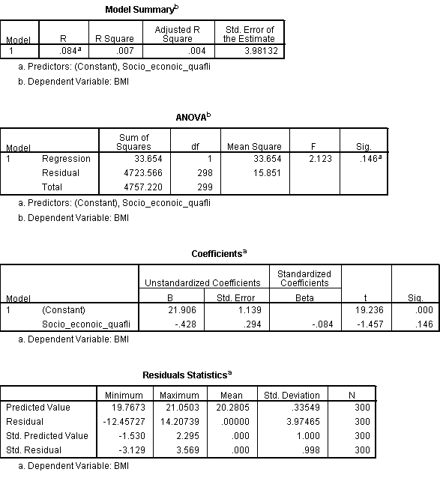

**BMI= 21.906-0.426(Socioeconomic status)**

**Following table shows linear relationship between the two variables (BMI and AGE )**



Chi chart of Gender with exercise

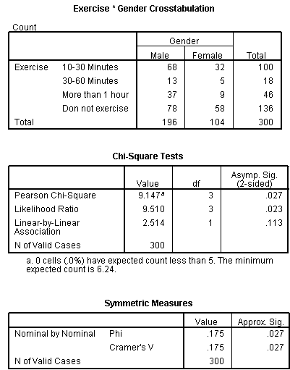

Chi chart of Gender with Nutrition supplement

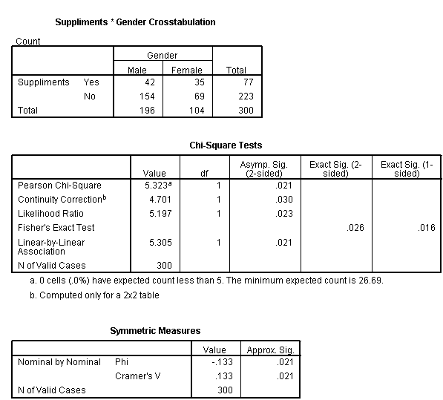

| **Case Processing Summary** | | | | | | |
| --- | --- | --- | --- | --- | --- | --- |
|  | Cases | | | | | |
|  | Valid | | Missing | | Total | |
|  | N | Percent | N | Percent | N | Percent |
| Socio_econoic_quafli * Suppliments | 300 | 100.0% | 0 | .0% | 300 | 100.0% |

Only 25 % take food supplements

| **Socio_econoic_quafli * Suppliments Crosstabulation** | | | | | |
| --- | --- | --- | --- | --- | --- |
|  |  |  | Suppliments | | Total |
|  |  |  | Yes | No |
| Socio_econoic_quafli | Lower | Count | 6 | 17 | 23 |
| Std. Residual | .0 | .0 |  |
| Lower Middle | Count | 11 | 48 | 59 |
| Std. Residual | -1.1 | .6 |  |
| Upper Middle | Count | 44 | 129 | 173 |
| Std. Residual | .0 | .0 |  |
| Upper | Count | 16 | 29 | 45 |
| Std. Residual | 1.3 | -.8 |  |
| Total | | Count | 77 | 223 | 300 |

| **Chi-Square Tests** | | | |
| --- | --- | --- | --- |
|  | Value | df | Asymp. Sig. (2-sided) |
| Pearson Chi-Square | 3.839a | 3 | .279 |
| Likelihood Ratio | 3.790 | 3 | .285 |
| Linear-by-Linear Association | 2.003 | 1 | .157 |
| N of Valid Cases | 300 |  |  |
| a. 0 cells (.0%) have expected count less than 5. The minimum expected count is 5.90. | | | |

**Conclusion**

SES study have methodological and conceptual limitation.by providing an important approach from which to examine the influence of social factors on BMI by which we can predict obesity level of any person.

BMI effected by Socio economic status as our results shows that from lower to upper class BMI is decreasing from 21 to 19.

By improving the socioeconomic status of people The strengths of this study include mixed qualitative and quantitative methods. The collection of both quanti- tative data (such as heights and weights for BMI) and qualitative data through unstructured and semi-struc-tured interviews allows for statistical testing supported by qualitative analysis

This study’s small sample size limits However, much of the qualitative ethnographic and interview data supported the quantitative findings. Although useful for international comparison, BMI contains limitations in measuring body fat percentage, visceral adipose tissue and central obesity

Exposure to under nutrition, infection, poverty and war may lead to stunting and short stature (Bogin et al., 2007). Because of their short stature, particularly in the legs, BMI measure- ments might overestimate obesity among the Guatemalan Maya (Smith et al., 2003). The measurement of waist circumference may be a viable alternative in determining central obesity (McCarthy, 2006; Groenveld et al., 2007).

The causal pathways approach to the understanding of SES and obesity might be a powerful tool for health disparities research. To the extent that mediation analysis allows us to identify mechanisms that underlie health There are several limitations to the present findings one of them is that height and weight were measured via self­report, which might have resulted in some underreporting bias

disparities (associations between SES or ethnicity and disease), it allows us to address the causal mechanism that under lies the disparity

In summary, we conducted an analysis that suggests there must be social awareness regarding Obesity and BMI among the people through electronic media. Government have to take more further steps to to increase the socioeconomic status of people by providing them Education and better jobs. We must follow   World Health Organization’s general recommendations to combat obesity include the promotion of active lifestyles, the restriction of television viewing, the promotion of fruit and vegetable consumption, and the restriction of energy dense and sugary foods and drinks.